Web Application Project Progress Report

The report should be organized chronologically and by technical component, ensuring all key areas of the project are addressed.

1. Project Overview and Status
This section sets the context and provides a high-level summary.

a. Project Information:
Project Title and Team Members.
Course and Date of Submission.

b. Current Status Summary:
A brief, one-paragraph statement summarizing the project's overall health (e.g., "The project is 70% complete. All core backend APIs are functional, and the front-end login/registration modules are integrated. We are currently implementing the main data display features.").

c. Progress Against Original Plan:
Compare the current progress against the original project timeline or plan (if they submitted one). Identify any major delays or accelerations.

2. Development Progress (Since SRS)
This is the core technical section and should detail the work completed since the requirements were finalized.
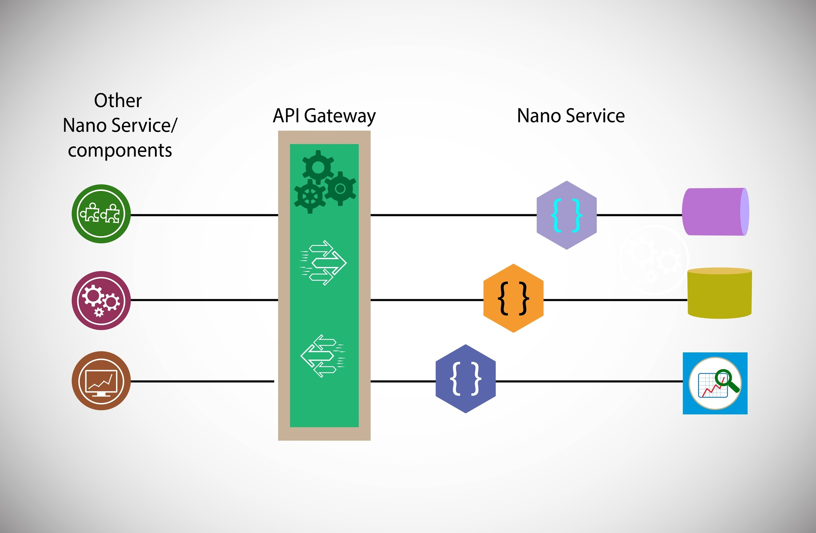
Source: Shutterstock

Backend Implementation
- Database Schema: Briefly describe the key tables/collections created and their purpose. Include a simple Entity-Relationship Diagram (ERD) or schema snippet.
- API Implementation: List the major APIs/endpoints that are fully functional (e.g., POST /api/users/register, GET /api/data/{id}).
- Authentication/Authorization: Describe the mechanism used (e.g., JWT, session-based) and confirm its implementation status.

Frontend Implementation:
- Key Components/Pages: Detail the main pages or components that are fully built and integrated with the backend (e.g., User Dashboard, Navigation Bar, Data Entry Form).
- User Interface (UI) Status: Describe the use of any CSS framework (e.g., Bootstrap, Tailwind) and the general progress on meeting the UI/UX goals from the SRS.

3. Verification and Testing
This section proves that the implemented features are working correctly.

Unit Testing:
  - Coverage: Report on the percentage of code covered by unit tests (if applicable) or list the key modules/functions tested.
  - Framework: Mention the testing framework used (e.g., Jest, Mocha).

Integration Testing:
  - Describe how the front-end and back-end are tested together. Provide a brief example of a successful end-to-end test case (e.g., "Testing 'User Registration' involves a POST request to the API followed by verifying the new record in the database and successful login.").

Issues/Bugs Found:
- List any major bugs encountered and whether they have been resolved.

4. Technical Challenges and Solutions
This demonstrates critical thinking and problem-solving skills.

Challenges Faced:
Identify 1-3 significant technical hurdles the team encountered (e.g., "Difficulty configuring a secure connection to the third-party API," or "Performance bottleneck with large database queries").

Solutions Implemented:
Explain clearly how each challenge was resolved and what was learned in the process.

5. Proposed Work Plan (Next Steps)
This section provides a forward-looking perspective.

Remaining Tasks:
List the top 3-5 remaining features to be implemented before the final deadline.

Revised Timeline (if changed):
Outline the plan for completing the remaining work and the tentative schedule for the final testing/deployment.

Report Submission Guidelines

Format
Should be submitted as a single PDF document.

Length
A suggested length of 5-8 pages (excluding appendices) is usually sufficient for a progress report.

Appendices (Optional but Recommended)
Include relevant code snippets, screenshots of the working application (e.g., login screen, dashboard), and the latest database schema.
A report template is provided for your reference.

Viva Preparation
For the follow-up viva, one should focus on the process, the technical choices, and the critical thinking demonstrated in the report.

